**USER GUIDE**

**Android Application**

* Open GPS Track Application
* Enter User Name
* Enter Server IP Address
* Leave the port as it is
* Tab ‘Start’ Button

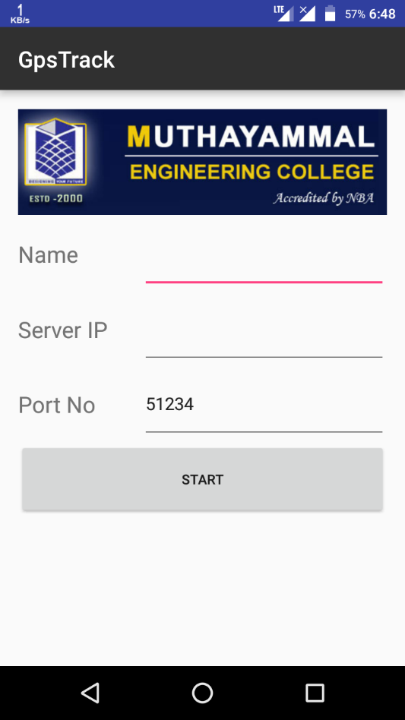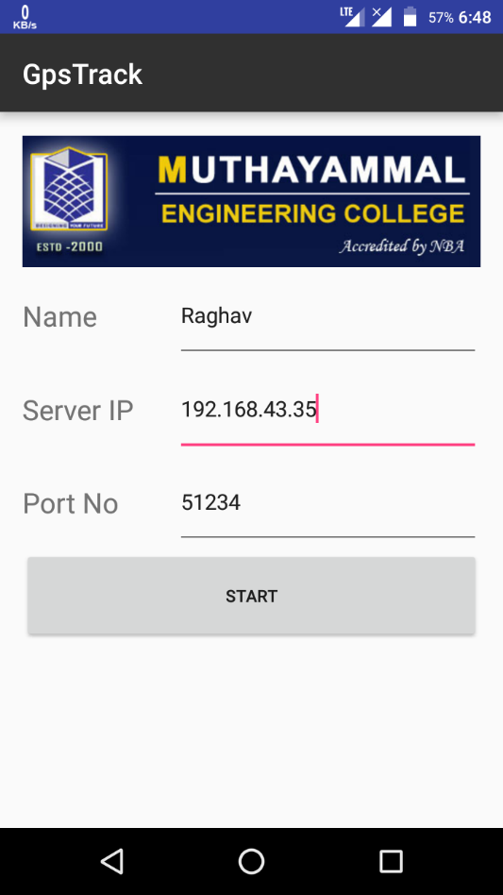

* Click ‘start’ Button

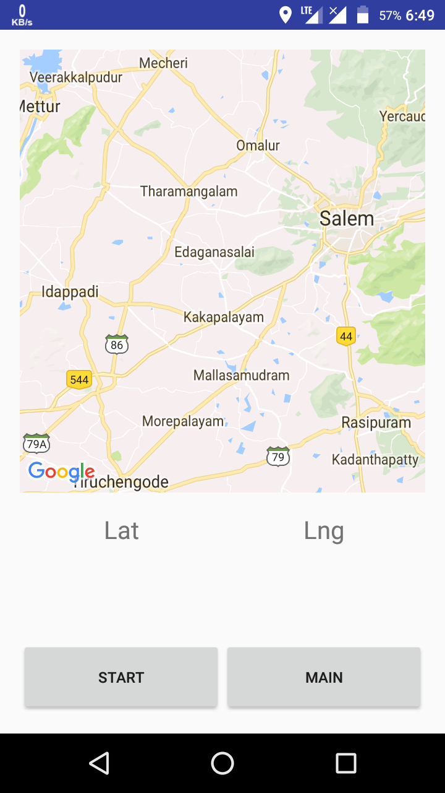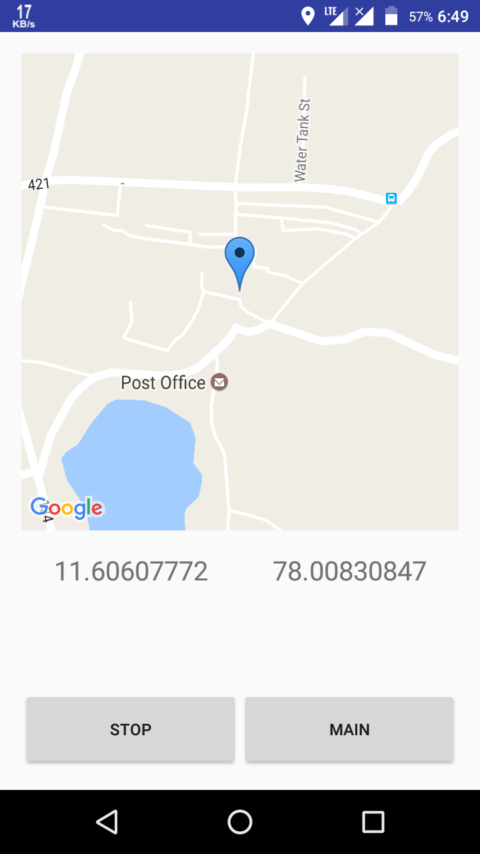

**Server**

There are two important steps to be performed in Server

* Java File
* Website

**Java File**

It receives the data from mobile and stores to Database

* Run the Java file

java DServer

Note:- You can mention port by java DServer <port> by manual otherwise don’t mention it

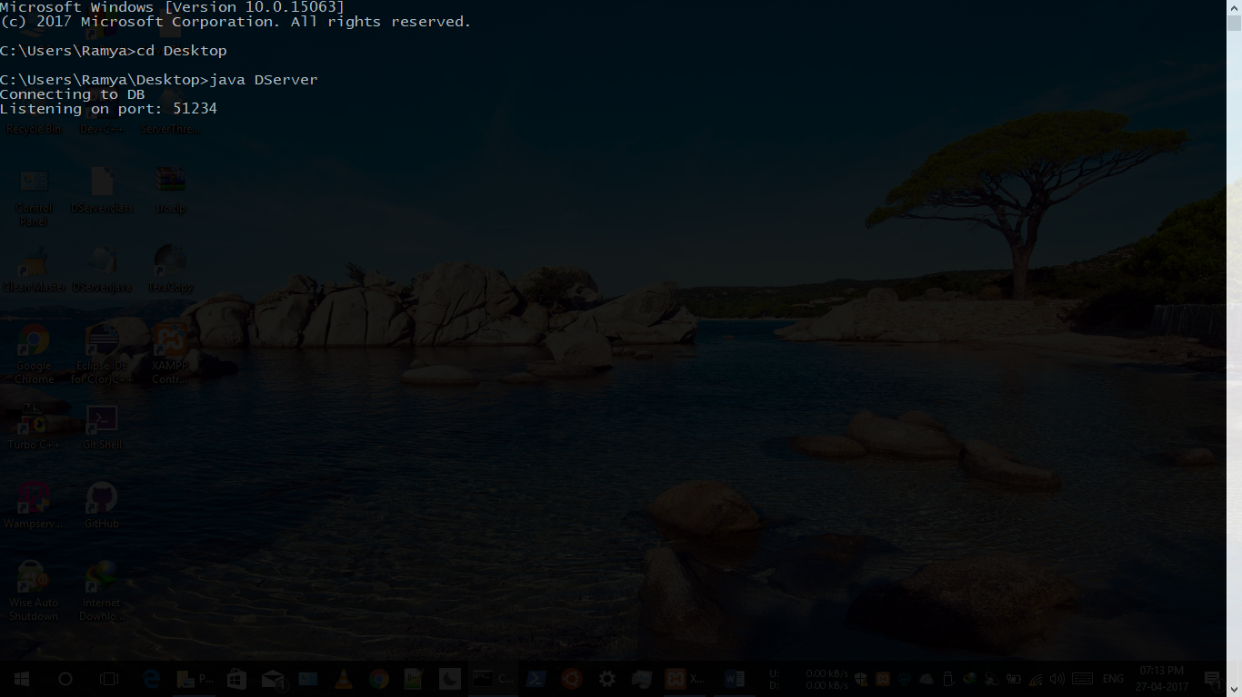

**Website**

Run with Apache

* Enter localhost in browser

